Positive Behaviour Management
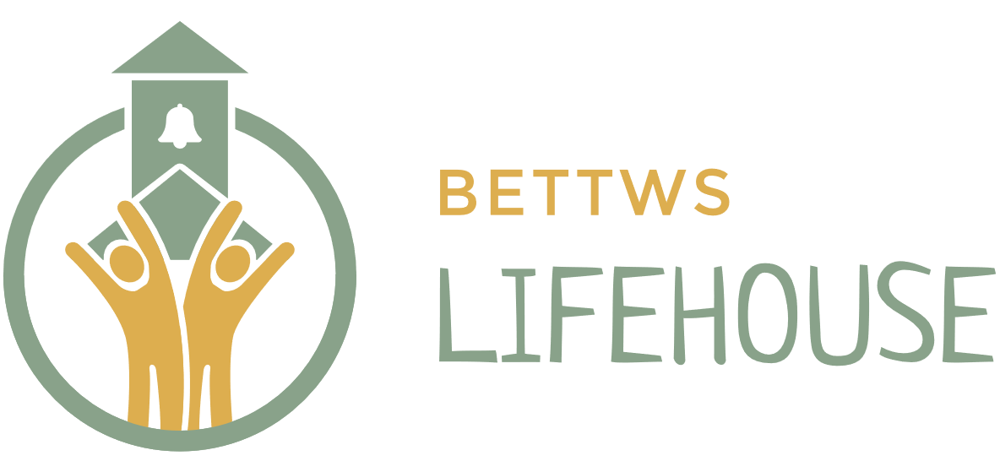

Most recent Review: June 2024, June 2025, June 2026
Next review: June 2027

Rationale

Positive behaviour management is the responsibility of all staff and the Lifehouse Community. It has to be a co-operative approach where we all work as a team & in partnership with the Team around the child. Mutual support, consistency and communication are an essential part of this team venture.

The Lifehouse recognises that safe and respectful behaviour and expected levels of care and consideration are fundamental to the smooth running of the community, to maintain our low-arousal environment, and for learning to be possible. Courtesy and consideration for others is a key issue in our expected outcomes and will be taught through example and all areas of the curriculum. This policy should be read in conjunction with our Anti-bullying Policy, Safe Touch Policy, Safe Handling Policy, Exclusion policy and Complaints policy.

Building and sustaining positive relationships is at the core of our school where the student has a felt sense of safety,
“I define connection as the energy that exists between people when they feel seen, heard, and valued; when they can give and receive without judgment; and when they derive sustenance and strength from the relationship.” Brene Brown

Our overall aims are:
- To promote good behaviour and enable learning
- To support pupils in learning self-awareness and self-discipline
- To enable effective teaching and learning
- To ensure safety, security and welfare of others
- To facilitate pupils and students to understand, accept and tolerate differences in themselves and others
- To teach pupils and students about socially appropriate and acceptable choices

All staff are responsible for maintaining the behaviour of the children in their care. We follow the Thrive, ‘Shining a light on behaviour’ process and the TIS Four pillars of belonging – Noticed, Known, Named and Needed.

Policy (including procedures for rewards, sanctions and exclusion)

Objectives:

- To help the child to recognise and begin to understand their own behaviour by constant and sensitive use of attunement, validation, containment and regulation.
- To help them to make the links between emotion, sensation and behaviour
- To lend your thinking brain to help them to name, sequence, and make links between cause and effect, actions and consequences.
- To reshape their own stress-regulation system so that they can sense STOP FEEL STOP, THINK, CHOOSE and ACT.
- To move a child that has ‘dysregulated’ back to a position where that can access their ‘thinking brain’.
- To reduce number and intensity of learner’s ‘dysregulations’
- To integrate the TIS model of PRRR – Protect, relate, regulate and reflect to our daily practise.

Expectations:

Expectation of Pupils

3 Golden Words: 1. Safe
2. Respect
3. Learn

- To engage
- To be aware of their behaviour
- To support others to learn
- To follow rules in respect of health and safety
- To make their best efforts to understand and accept differences in people, perhaps in relation to gender, race, disability, background or sexual orientation
- To respect property and not misuse, damage or take property belonging to The Lifehouse or others
- To sort out disagreements without resorting to verbal or physical violence. Be conscious that other appropriate adults can help to arbitrate in these issue.
- To make an effort to apologise when things have gone wrong, and show a willingness to learn from it and move on.
- To promote the Golden Words towards each other.
- To support each pupil to follow the Children’s Charter

Expectation of Lifehouse Staff

- To provide opportunity for pupils to learn to the best of their ability by setting suitable learning challenges, removing barriers to learning and accepting diversity of personality and ability
- To model the core values of Bettws Lifehouse: Kindness, Integrity, Acceptance, Aspiration, Balance and Positivity.
- To maintain a culture of professional curiosity by understanding the reasons for children's behaviour, including each pupils individual SEN, Risk Assessment and triggers.
- To ensure that the children who attend Lifehouse KNOW and UNDERSTAND Lifehouse expectations and boundaries and the system of reward and sanction.
- To provide an environment in which children can learn
- To provide opportunity for pupils to reflect on their behaviour choices, and to provide guidance and assistance to individuals as necessary – Eg this is in the form of 1:1 ‘watches’ during social times – to support appropriate interactions.
- To model mutual respect by treating pupils with fairness and consistency
- To model interpersonal skills by promoting positive supportive relationships (Use of Nurture and Pace model)
- To encourage and maintain good communication with home and the wider staff team and Champions – eg completing daily diaries to provide pertinent, specific and clear summaries of behaviours.

Expectation of Parents/Carers

- To ensure their child is encouraged and enabled to attend regularly
- To communicate with staff at The Lifehouse and let us know if there are any mitigating factors that may affect their child at any time
- To encourage and support their child in their learning experiences
- To support school staff in their decisions to manage the school day in everyone’s best interest
- To support the school’s core values and policies

Rewards

Encouragement, praise and reward are an essential part of positive behaviour. Verbal praise and encouragement should be part of every activity, including such aspects as achievement, effort and improvement. Our merit system (see below) recognises the importance of these areas. We will always acknowledge these things.

On a day-to-day basis we operate a learning diary. Positive and negative behaviours are recorded. Simple and easy instant rewards such as stickers and written / verbal comments will also be recorded in the diary. Staff use Zones of Regulation/Attitudes to Learning to summarise the lesson, this is then reflected upon with the Champion during Champion time.

Champions will monitor pupils’ behaviour and regulation and attitude to learning. With their champion, pupils will regularly look through learning diaries and reflect. Champions and pupil will discuss progress and areas of difficulty and these sessions will help to inform planning and pupil management.

Merit System

Each class (Brook, Spring and River) operate their own MERIT system which then leads to class and individual rewards for each pupil.

We will also reward examples of a child:
- Helping a new child settle in
- Showing initiative
- Being helpful in the wider community
- Showing themselves to be a good ambassador for The Lifehouse
- Helping willingly with jobs we all prefer not to do!
- Good attendance
- Determined effort in areas of personal weakness
- Sustained improvement
- Trying new things

A Head Teacher’s award is another reward that highlights exceptional achievement for a piece of work or an exceptional example of any of the above. These are awarded weekly during Friday AM assemblies.

Sanctions

We do not have a one size fits all approach to behaviour management. Our child centred approach requires behaviour management to be adaptable. However, a whole school approach is implemented for each individual pupil. Our Champion system is vital in terms of forming and communicating the whole school approach that is to be implemented by the staff team with regards to their pupil. For example periods of reflection during Champion time are core practise. During this time, for example a social story may be read to consolidate understanding about a specific interaction. See Champion handbook for further details.

If the behaviour is considered unacceptable and through a poor choice, then a ‘Time in’ (reflection time during breaktime/lunchtime – alongside an appropriate member of staff) may be issued. In most instances, the pupil is warned about their behaviour and will have opportunity to make a positive behaviour choice; there are times when an instant ‘Time in’ is imposed.

During ‘Time in’ staff will encourage pupils to reflect upon the reasons for their ‘Time in’ - often via social stories, comic strips or through conversation if appropriate. Resources for ‘Time Ins’ are child centred and individualised.

Alongside the ‘Time in’ system we also have ‘letters of apology’ which may need to be written on any occasion where staff feel an individual (staff or pupil) has been personally insulted or verbally abused eg sworn at directly. This may be completed during reflection time (see below) or during a ‘Time in’. The pupil will be supported and guided on the letter and its content.

If a pupil is deemed to have dysregulated or is behaving in a way that requires reflection at a later time, then this will be organised at an appropriate time with a member of staff, often with a specific focus or outcome

Minor disciplinary matters would not be reported to parents or other agencies unless they were being persistently committed.

Serious Misdemeanours

A serious incident relating to negative behaviour would be where someone had been physically assaulted or harmed, seriously verbally abused, damage to property and serious or repeated disruption to education, or where drugs, weapons or alcohol are involved. It may also include disregard for instruction that has endangered or put at risk the pupil and or others.

Safe handling/physical intervention may be necessary in some cases. Please read the associated policy.

In cases of a serious incident, an incident meeting will take place after school to provide staff an opportunity to reflect on the incident and agree consequences. Consequences may include:

A ‘Reflection time’: time to reflect with their champion
A ‘Time in’
A ‘letter of Apology’
An internal exclusion – within school - for all or part of a school day
An external exclusion – in cases of assault or potential assault, damage to or theft of property or serious disruption -and where an internal exclusion is considered neither manageable nor appropriate

It would be discussed with parents/carers and other involved parties.

The directors hold the right to immediately terminate a contract if an incident such as the above has taken place.

Exclusions

This part of the policy should be read alongside our ‘Exclusion policy’

In the instance of a child being sent home for the remainder of the day, this is considered an exclusion and would be recorded as a half day exclusion. Pupils are sent home because we have found that pupils need time to reflect, regulate and re-establish personal safety, and this is considered the best course of action for the pupil, for another pupil and for the school as a whole. This would only be considered if an internal exclusion was not possible or not appropriate. The remaining pupils also need their welfare considered and the effect a volatile situation has on their learning.

When a pupil is given a fixed term exclusion of a whole day or more, they may be asked to stay home because
- Staff consider the pupil’s negative behaviour warrants a period of exclusion
- Behaviour has been repeated several times
- Behaviour was extreme and has been disturbing/distressing/dangerous for others

The head teacher has the right to decide an appropriate length of time according to the severity of the incident. The head may also extend that period if they feel that the pupil is not ready to return or a multi-agency meeting needs to be convened. The safety of pupils and staff is always paramount.

Education Authorities will be informed every time an exclusion over one day takes place or a series of one day exclusions are imposed on any one pupil. This is in accordance with and beyond the expectation required by
– the Education (Pupil Exclusions and Appeals) (Pupil Referral Units) (England) Regulations 2008.

All negative behaviour incidents – requiring physical intervention or not - are logged onto CPOMS (including witness statements),

Should any interested party wish to appeal against a decision involving fixed term or permanent exclusion or termination of a contract, then the appeal should be made through our Complaints policy.

Date of Amendments/Review | By Whom
26/06/2024 | Fiona Davies
29/05/2025 | Fiona Davies
20/05/2026 | Fiona Davies, Kieran King, Tracey Edwards, Emma Lewis, Sam Williams, Tim Harrison

